SQL server gives you useful information on how it’s using its indexes. To open the report go in Reports 🡪Standard Reports 🡪 Index Usage Statistic

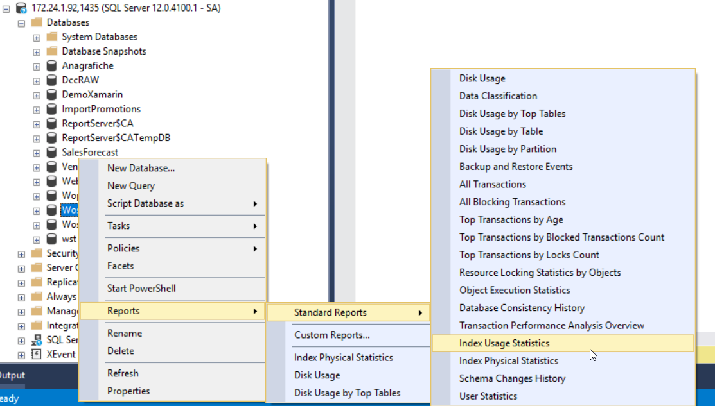

The 3 important columns are ‘#User seek‘, ‘#User scan’ and ‘#user updates’

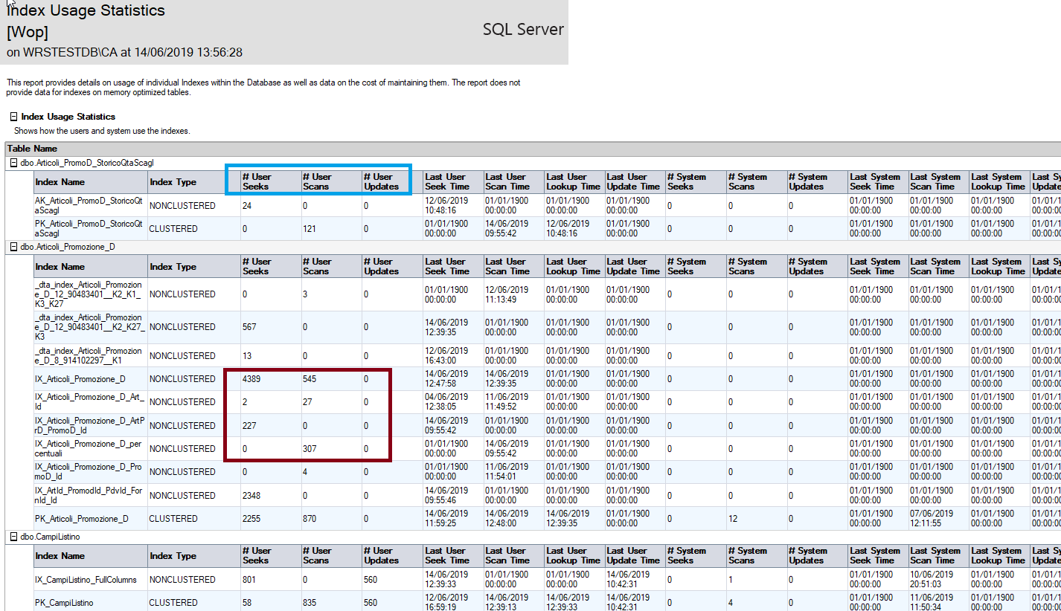

The number of **Seeks** indicates the number of times the index is used to find a specific row, the number of **Scans** shows the number of times the leaf pages of the index are scanned, thenumber of **Updates** shows the number of times the index data is modified. The result in our case will be like the below. An optimal index has a low update value (expensive operation) and a high read value: an index that changes rarely but is often used.

On the other hand an index of this type:

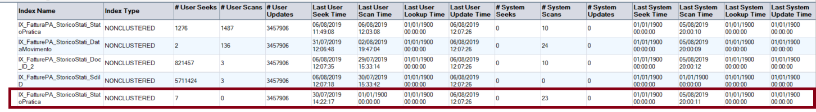It’s absolute terrible with only 7 reads and 3457906 updates, maybe it should be deleted.

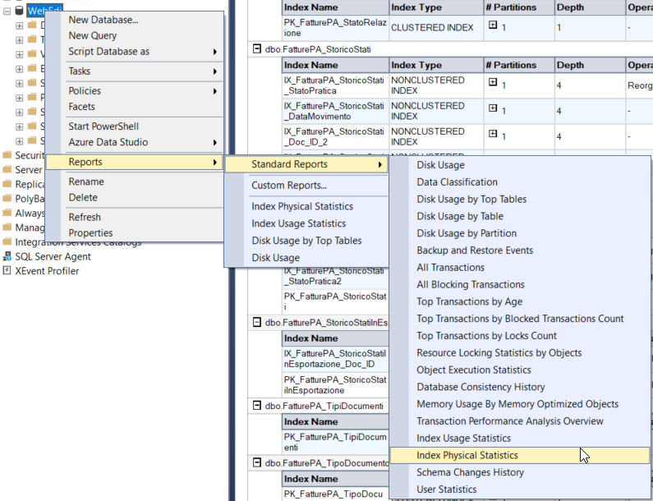Another useful index page is the ‘Index Physical Statistic’:

Shows the state and the recommended operation for each index in the db:

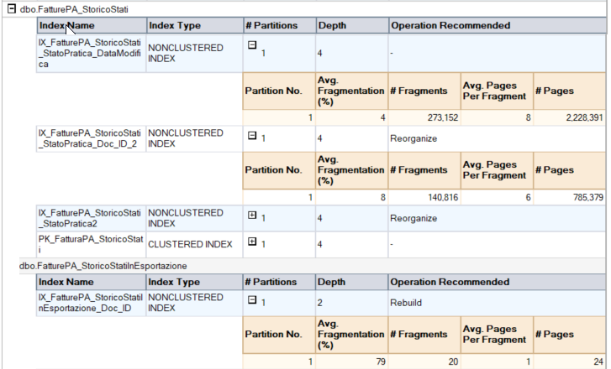

The most important information is the ‘Avg Fragmentation (%)’, its value dictates the maintenance operation required by the index:

* With a value under 5% no operation are required
* With a value between 5% and 30% use command ‘ALTER INDEX REORGANIZE’
* With a value greater than 30% use command ‘ALTER INDEX REBUILD’

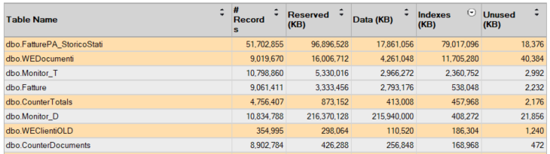Last report worth looking is the ‘Disk Usage by table’:

This table shows the number of records and the disk usage for each table. The disk usage is divided in two:

* Space used for the real data ‘Data(KB)’
* Space used for the index ‘Indexes(KB)’

If a table use a disproportional high part of its disk space for indexes (The first line has an incredible 4.3 ratio) maybe there are too many index and same are not used anymore. This is not always the case before deleting an index always check its usage rate in the previous report.